“The Tell-Tale Heart” by Edgar Allan Poe

Activity Packet

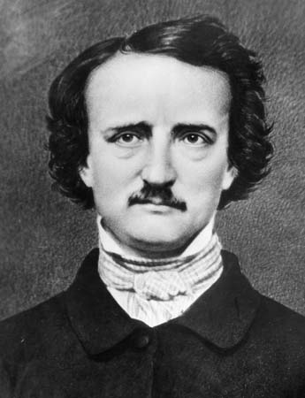

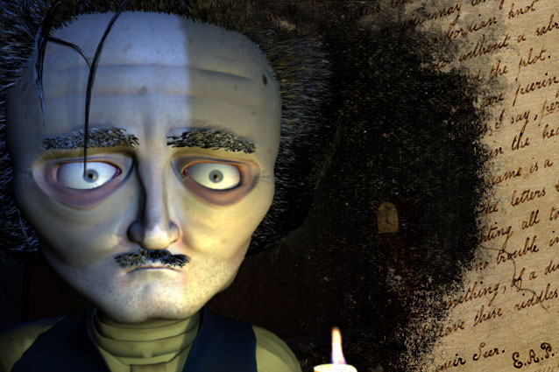

Name ____________________________________________ L.A. Period ________

Your score ___________out of 30 points possible
( Covers plot elements, comprehension, figurative language,
mood, character traits, , and setting )

Pre-Reading Guide for “Tell-Tale Heart”

Name _________________________________________ Period ___________ (5 pts.)

Describe five things that you usually find in a scary/horror story:

1. ______________________________________________________________

2. ______________________________________________________________

3. _______________________________________________________________

4. _______________________________________________________________

5. ________________________________________________________________

Read the following statements. If you agree with them, put a check in the YOU column. Then, AFTER we read the story, go back and put a check in the AUTHOR column if you feel the author agrees with that statement.

YOU AUTHOR STATEMENT

____ ________ 1. People who are insane know that they are insane.

____ ________ 2. Sane people sometimes imagine that they hear things.

____ ________ 3. If you commit a crime, the worst punishment is the guilt
afterward.

____ ________ 4. Often it’s the small annoying things about people that
can be the most irritating and infuriating.

____ ________ 5. All people are basically afraid of the same things.

____ ________ 6. When you’ve done something wrong, wondering if you’ll
be caught can cause great stress and anxiety.

“Tell-Tale Heart”comprehension Questions Name__________________ (20 pts.)

After reading “Tell-Tale Heart” by Poe, answer the following questions using short answers. They do not need to be complete sentences, but answer each part of the question thoroughly.

1. Who is telling this story (narrating)? Is it first, second, or third person?

2. What is your first impression of the narrator? What does he try convincing the reader
of?

3. How does the narrator feel about the old man in general? What, then, specifically, is
it about the old man that troubles/bothers the narrator? Why? How often does the
narrator mention this “thing” in the story?

4. What does the narrator tell us he does every night? Why?

5. How does the narrator feel immediately after he commits the murder? Do his
feelings change? If so, how and why?

“Tell-Tale Heart” Comprehension Questions continued… Name__________________

6. What sound drives the narrator to confess to the crime? What do you think
causes his paranoia?

7. Give two direct and specific examples from the story that the author uses to
create an atmosphere of horror or suspense. These are sentences that set or
enhance the MOOD of the story. Give the page number.

8. Give one example where the author uses punctuation or repeated words or
phrases in a sentence to show the mood of horror or suspense.

9. Find one example of each of the following:

a. Alliteration – Pg. ___ ___________________________________________________________

_______________________________________________________________________________

b. Simile – Pg. ____ ____________________________________________________________

__________________________________________________________________________________

10. c. Personification – Pg. ___ ______________________________________________________

_______________________________________________________________________________

d. Assonance – Pg. ____ ________________________________________________

